**BSc (Hons) in Information Technology**

**Software Engineering – Year 3 Semester 2, 2022**

**SE3050 – User Experience engineering**

**Milestone 03**

**Team BIKO - SER_027**

IT20150266 Basnayaka A.I

Table of Content

Identification of the fail points …………………………………………………………………………………………………………………………03

* Fail point -01 ……………………………………………………………………………………………………………………………………….05
* Fail point -02 ……………………………………………………………………………………………………………………………………….06
* Fail point -03 ……………………………………………………………………………………………………………………………………….07
* Fail point -04 ……………………………………………………………………………………………………………………………………….08
* Fail point -05 ……………………………………………………………………………………………………………………………………….09

User Key flows …………………………………………………………………………………………………………………………………………………10

* Diagram 01 …………………………………………………………………………………………………………………………………………10
* Diagram 02 …………………………………………………………………………………………………………………………………………11
* Diagram 03 …………………………………………………………………………………………………………………………………………12

Identification of the fail points

Milestone 01 User flow diagram

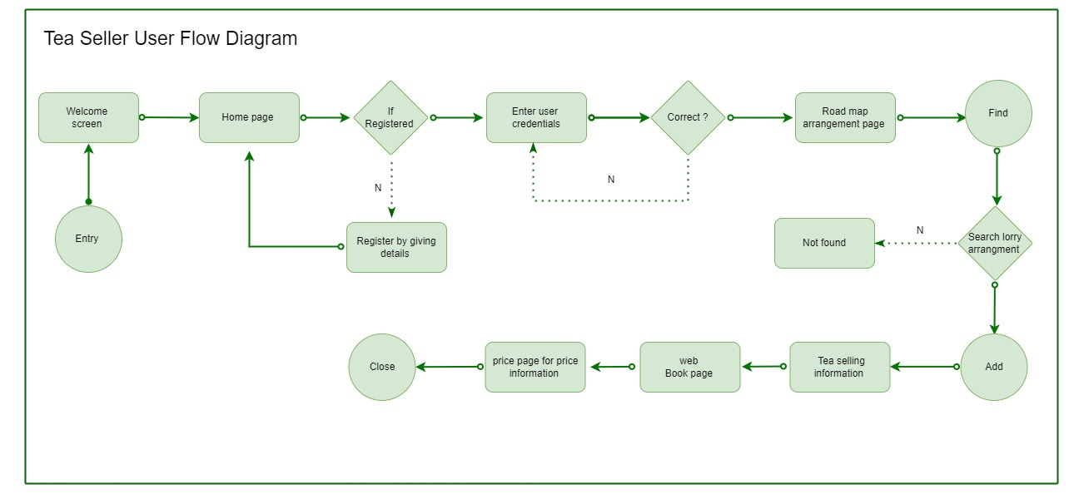

4

5

3

2

1

Identified user flow fail points

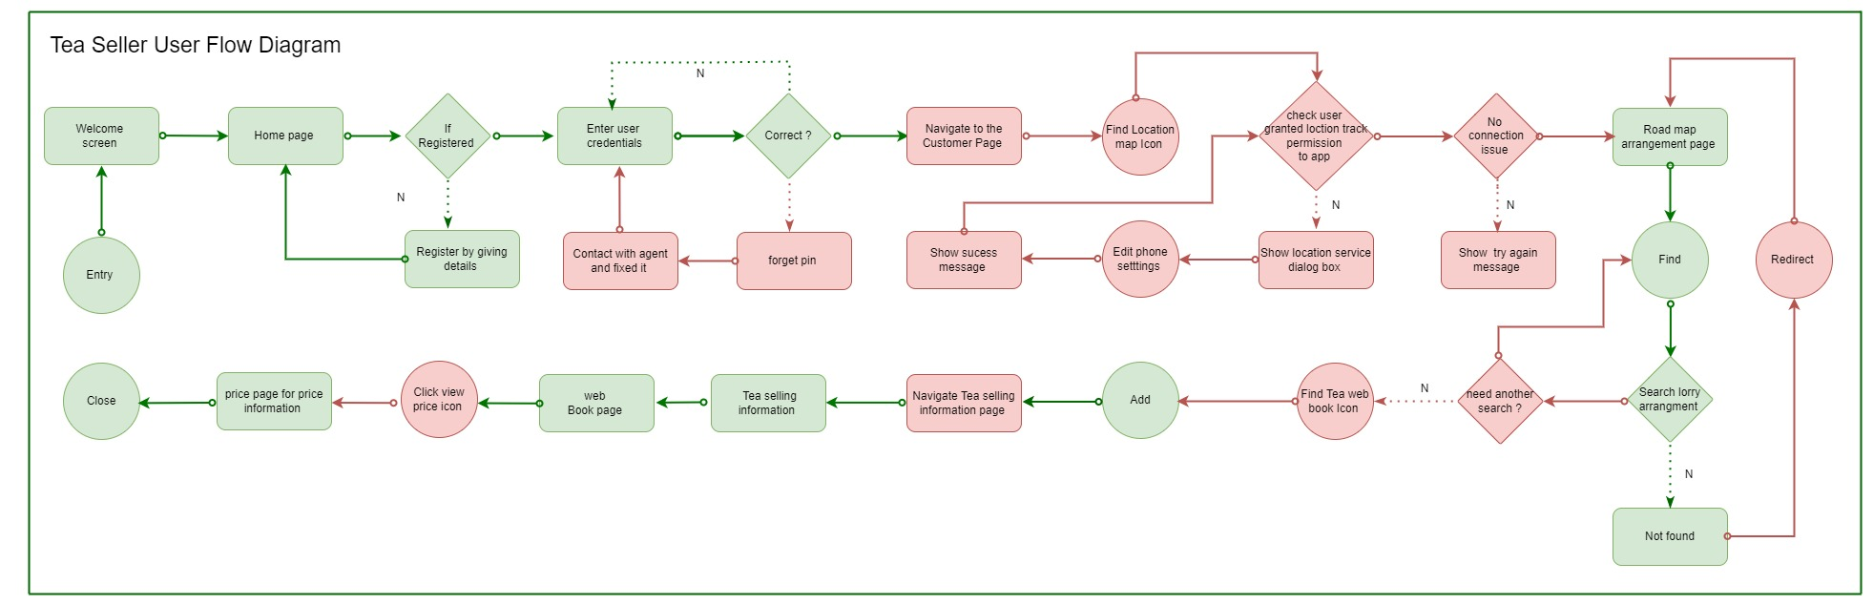

5

4

3

2

1

After completing the milestone 2, I can identify some fail points and blockings that we have done in milestone 1 user flow diagram.

In the user research, I identified some blockings with referring to the activities we have already done.

**Fail point – 01**

****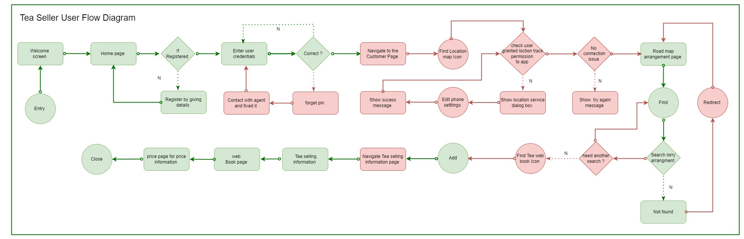

🡪

In here identified fail point is, if user forgot the user credentials, there is no option for user to continue flow to complete the scenario.

By considering the user research and according to the user requirement I introduce the forgot pin option to contact the agent and fixed the issue.

I ignore the OTP method and verify Tea seller by mail methods because of the lack of device operation knowledge.

Here in the user interview tea seller mention that they have not much knowledge in the Mobile application operation. They have only one smart phone for fulfill their children academic work. Usually, they used button phone therefore it is better to contact agent for fixed the issue

Video Link: <https://drive.google.com/drive/folders/1rWspk_ER7TADtETgKVFO8nsQHG0lgQRy?usp=sharing>

Time: 4.31s to 4.50s

**Fail point – 02**



🡪

In here identified fail point is, after successfully completing the onboarding process user need to navigate to the Tea seller dashboard where the all the necessary Icons and options available.

By considering the user research and according to the user requirement it is needed to introduce the Tea seller dashboard which including icons.

But in the user flow diagram this dashboard navigation is not mentioned. Therefore, I identified this as the failure point because user have no idea about what happen in next in the scenario and user blocking the action due to lack of user friendliness.

In the seller user flow, it must consider the user friendless with obey to the seller requirements

Video Link: <https://drive.google.com/drive/folders/1rWspk_ER7TADtETgKVFO8nsQHG0lgQRy?usp=sharing>

Time: 4.31s to 4.50s

Not only that in the user flow I add map feature to the app for give recognition to user to find the lorry place in that case when using the app, App required the location access permission to function the action. But in the user flow in milestone 01 that did not mention. So it also other blocking in the user flow.

That blocking also corrected as above.

**Fail point – 03**



🡪

In here identified blocking is, after search the lorry arrangement details if the lorry details not found user is block in that point so that I change the user for to redirect to the Road arrangement page in order to the complete the action perform by the user.

**Fail point – 04**





🡪

In here identified blocking is, after search the lorry arrangement details there is no option to navigate tea selling information page so that user need to certify whether user need to continue the search again or not, if not user can click the web book icon and navigate to the web book page

**Fail Point – 05**





🡪

In here identified fail point is, after search the lorry arrangement details User can add Tea harvest according to the user preference. But here it directly navigates to the Tea selling information. According to the user experience it is bad experience for the user so that by considering the user requirement it is need to add Tea selling information page.

Not only that in scenario if user need to recognize the price details, but user also need to click the icon before navigating to the price page.

Key User flows

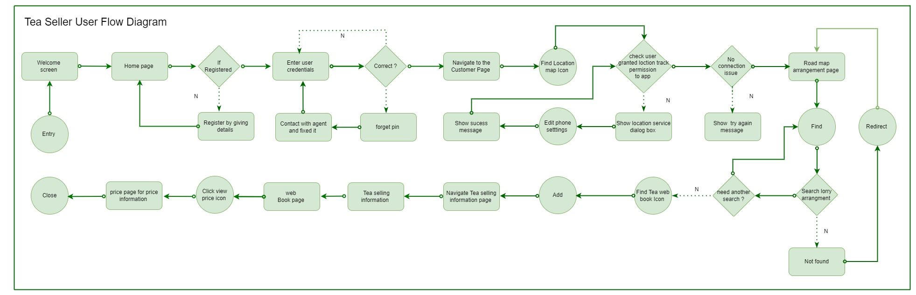

Diagram – 01

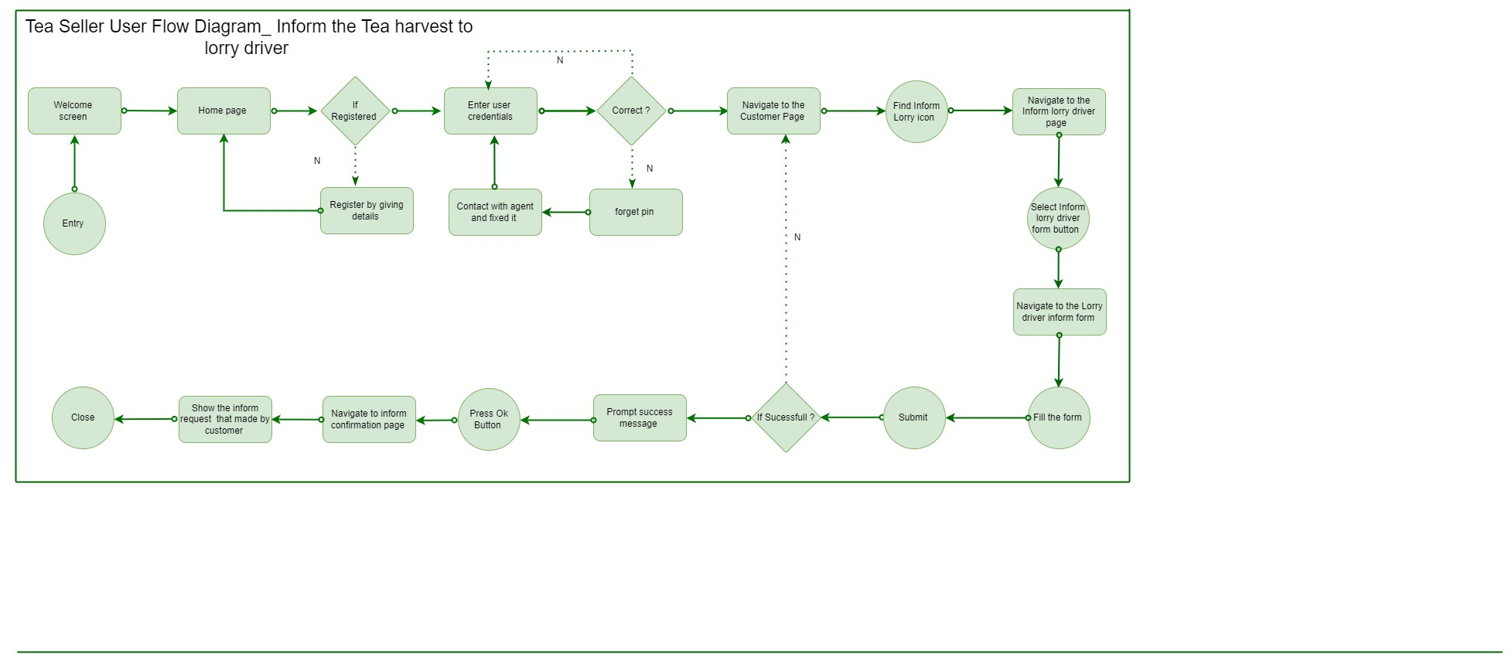

Diagram – 02

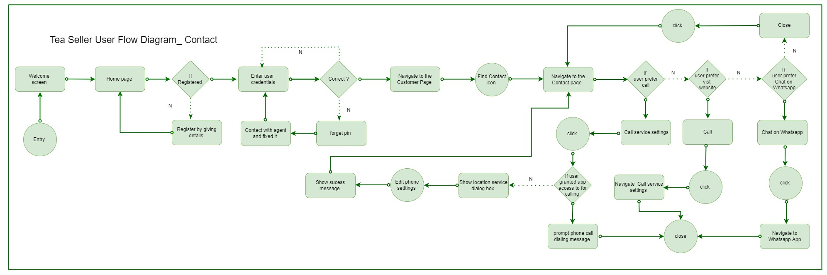

Diagram – 03